import 'package:flutter/material.dart';

void main() {

  runApp(MyApp());

}

class MyApp extends StatelessWidget {

  @override

  Widget build(BuildContext context) {

    return MaterialApp(

      home: ImageCycleScreen(),

    );

  }

}

class ImageCycleScreen extends StatefulWidget {

  @override

  _ImageCycleScreenState createState() => _ImageCycleScreenState();

}

class _ImageCycleScreenState extends State<ImageCycleScreen> {

  int currentImageIndex = 0;

  List<String> imagePaths = [

    'Ss/s1.jpeg',

    'Ss/s2.jpeg',

    'Ss/s3.jpeg',

    'Ss/s4.jpeg',

    'Ss/s5.jpeg',

  ];

  void changeImage() {

    setState(() {

      currentImageIndex = (currentImageIndex + 1) % imagePaths.length;

    });

  }

  @override

  Widget build(BuildContext context) {

    return Scaffold(

      appBar: AppBar(

        title: Text('Image Cycle'),

      ),

      body: Center(

        child: Column(

          mainAxisAlignment: MainAxisAlignment.center,

          children: [

            Image.asset(

              imagePaths[currentImageIndex],

              width: 200,

              height: 200,

            ),

            SizedBox(height: 20),

            ElevatedButton(

              onPressed: changeImage,

              child: Text('Change Image'),

            ),

          ],

        ),

      ),

    );

  }

}

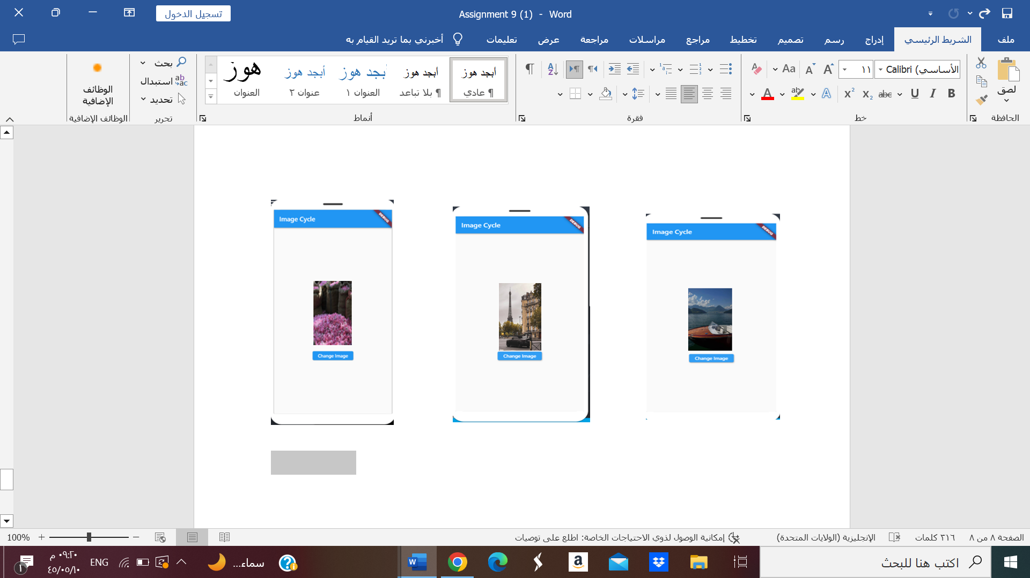

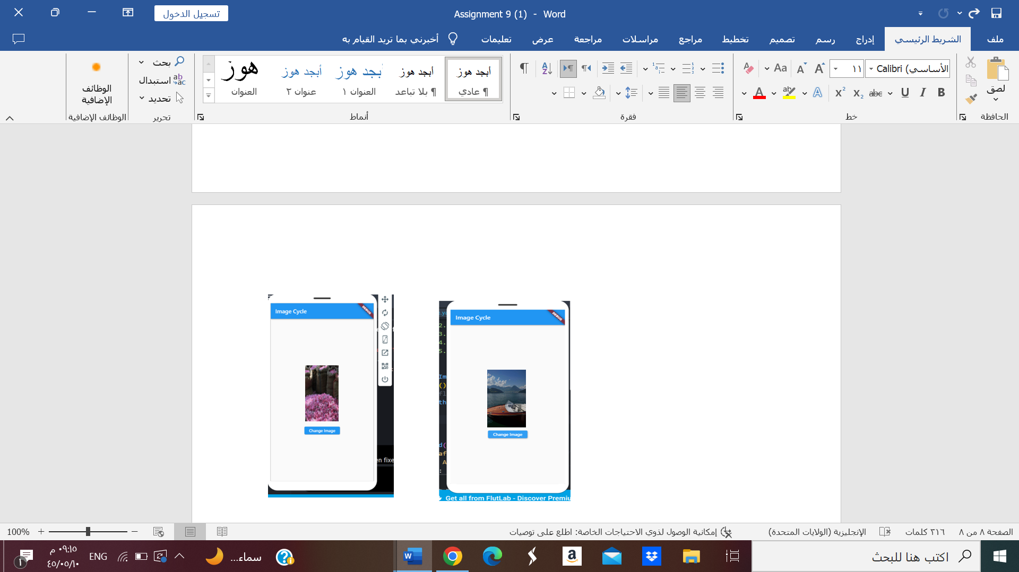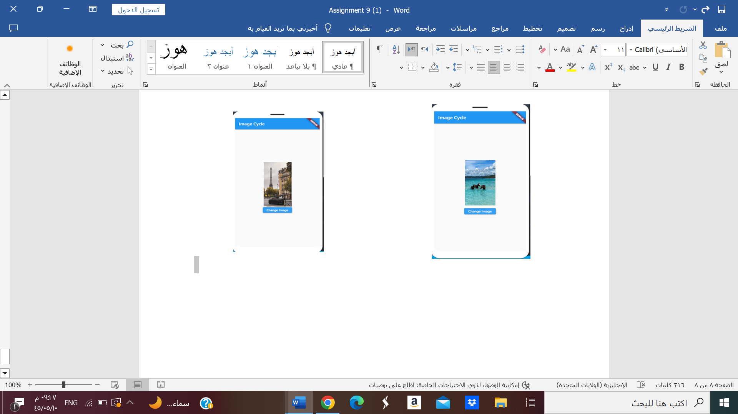

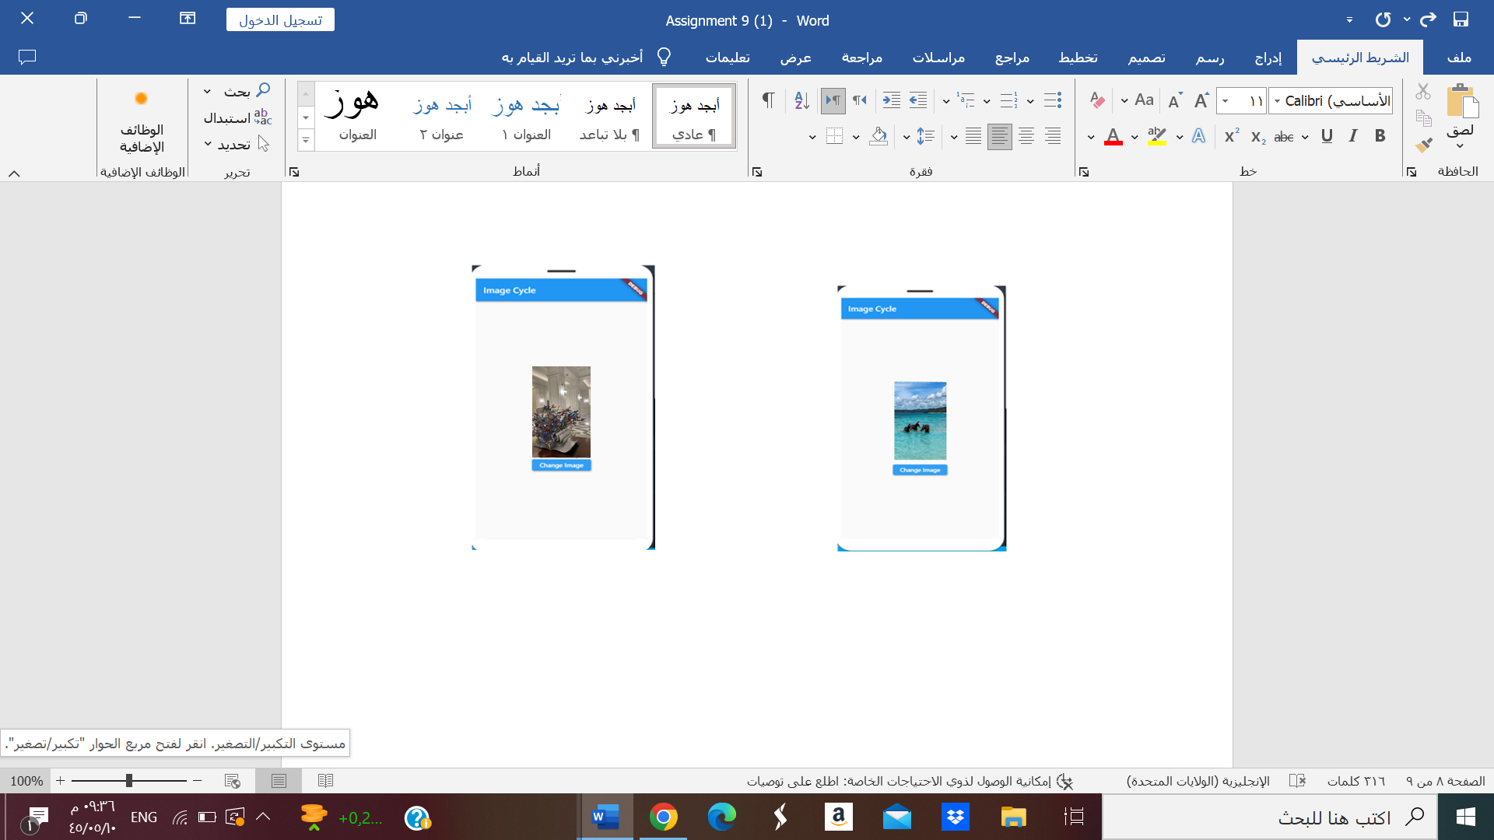

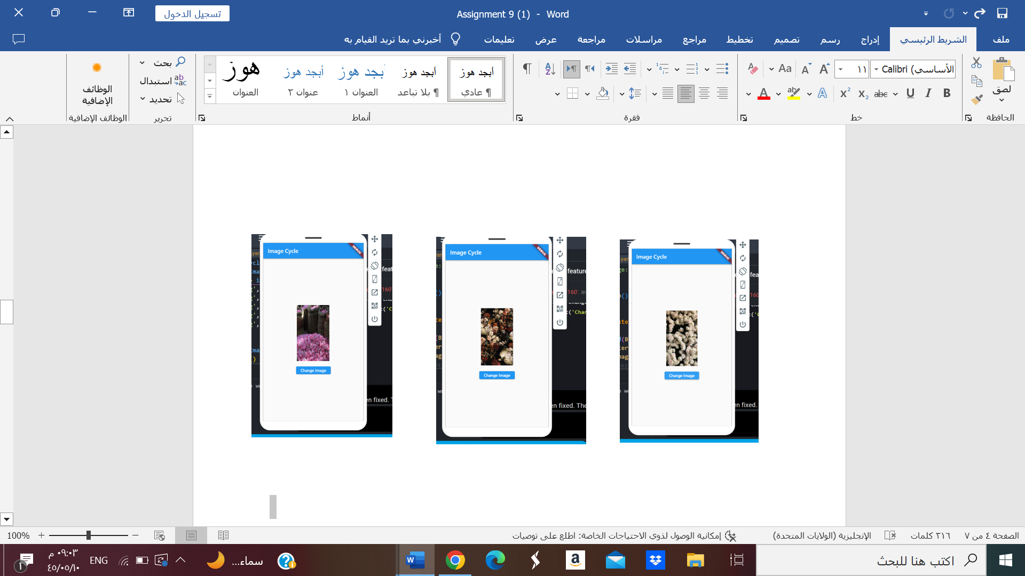

import 'dart:math';

import 'package:flutter/material.dart';

void main() {

  runApp(MyApp());

}

class MyApp extends StatelessWidget {

  @override

  Widget build(BuildContext context) {

    return MaterialApp(

      home: ImageCycleScreen(),

    );

  }

}

class ImageCycleScreen extends StatefulWidget {

  @override

  _ImageCycleScreenState createState() => _ImageCycleScreenState();

}

class _ImageCycleScreenState extends State<ImageCycleScreen> {

  int currentImageIndex = 0;

  List<String> imagePaths = [

    'Ss/s1.jpeg',

    'Ss/s2.jpeg',

    'Ss/s3.jpeg',

    'Ss/s4.jpeg',

    'Ss/s5.jpeg',

  ];

  void changeImage() {

    setState(() {

      // Shuffle the list of image paths

      imagePaths.shuffle();

    });

  }

  @override

  Widget build(BuildContext context) {

    return Scaffold(

      appBar: AppBar(

        title: Text('Image Cycle'),

      ),

      body: Center(

        child: Column(

          mainAxisAlignment: MainAxisAlignment.center,

          children: [

            Image.asset(

              imagePaths[currentImageIndex],

              width: 200,

              height: 200,

            ),

            SizedBox(height: 20),

            ElevatedButton(

              onPressed: changeImage,

              child: Text('Change Image'),

            ),

          ],

        ),

      ),

    );

  }

}





